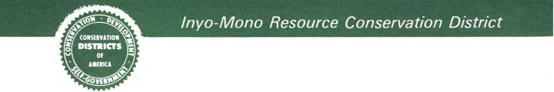

**Inyo-Mono Resource Conservation District Meeting**

When: Monday April 10th at 6pm

Where: County Building, 1360 N Main St Bishop CA, Room 101

Contact: Mikhala Bornstein (760)872-6111, (603)339-7099

Agenda

* Janet Hatfield, White Bark Institute, grant opportunities about forest restoration in the Eastern Sierra
* Review and adjust long range plan
* Board position decisions, vote
* Approve 3/20 meeting minutes
* Review website
* Member interest discussion – do we repost vacancy or wait?
* Alternate member discussion – is there any interest?
* Tree sales/ windbreak sales discussion – do we want to plan a tree sale for 2024 spring
* CSDA
* CA RCD tier 1
* Do we want to fund range camp or scholarships this year, how much, put to vote
* Creating and adopting remainder of FY23 budget, voting on said budget
  + Next FY budget needs to be submitted by August, discussion
* RCD board signs signature Authorization for Auditor-Controller
* Public comment

USDA is an equal opportunity provider, employer, and lender.