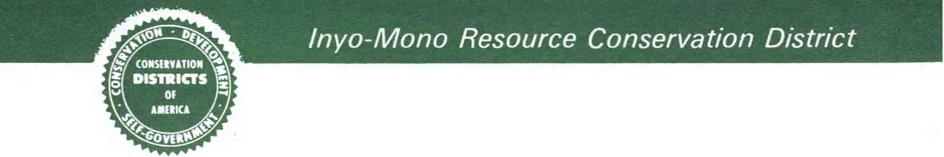

**Inyo-Mono Resource Conservation District Meeting**

When: Monday March 20th at 5pm

Where: County Building, 1360 N Main St Bishop CA, Room 101

Contact: Mikhala Bornstein (760)872-6111, (603)339-7099

Agenda

* Danielle Sexton, who works for the county with elections etc, will be at the meeting at five to give the Oath and swear in the four RCD applicants.
* Introductions
* We still have one opening on the RCD board.
* We have openings for people who wish to be “alternates”, but not serve on the board.



USDA is an equal opportunity provider, employer, and lender.